Lab 1: Vibration Signal Analysis Using FFT
Three-Axis Accelerometer Data from a Motor Run-Up (0 to Maximum RPM)
Michaël McCorkell | Humber College | October 2026

1. Objective
The objective of this lab is to analyse vibration data recorded from a motor while its speed was increased from zero to maximum RPM. The signals from three accelerometers (IIS2DH, IIS3DWB and ISM330DHCX) are transformed to the frequency domain using an FFT with a Hanning window. The accelerometer settings (dynamic range and sampling rate) are taken from DeviceConfig.json, the maximum frequency visible in the FFT of each sensor is identified, and the FFT and waterfall plots are presented for the z-direction.

2. Experimental Setup
A red electric motor is mounted on an aluminum extrusion rail. The accelerometer board is attached to the top of the motor housing and connected by a USB cable. The data used is from the folder 20260921_19_16_09, covering a run of roughly 20 seconds in which the motor speed is ramped from zero to maximum RPM.
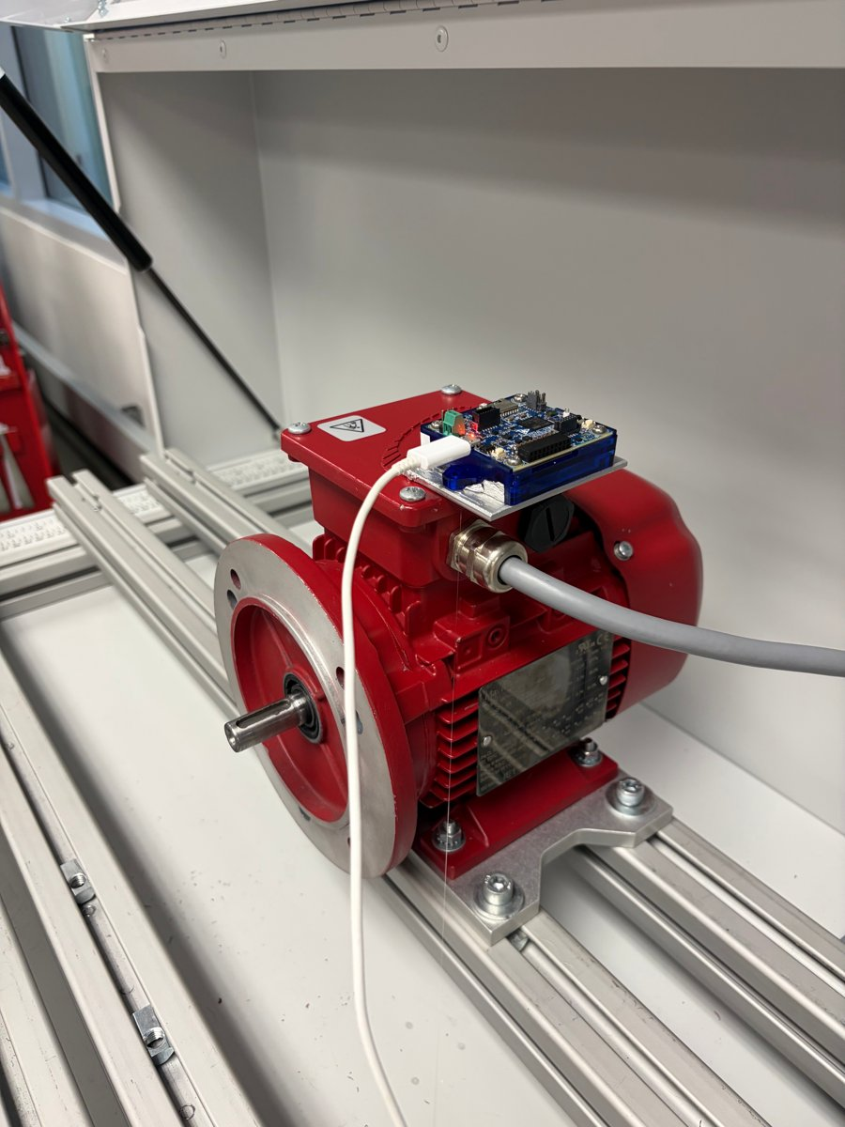
Figure 1. Test setup: accelerometer board mounted on the motor housing.
Accelerometer | Dynamic range | Config line (fs) | Sampling rate
IIS2DH | ±16 g | Line 344: "fs": 3 | 100 per second
IIS3DWB | ±4 g | Line 145: "fs": 1 | 1000 per second
ISM330DHCX | ±64 g | Line 262: "fs": 5 | 1000 per second
Table 1. Accelerometer settings read from DeviceConfig.json (see Section 4).

3. Question 1: FFT of Each Accelerometer
An FFT with a Hanning window was applied to the signals of each accelerometer. For each sensor the figures show the time history, the FFT magnitude, and the combined FFT magnitude and phase plot. Plots are shown over a 0 to 60 Hz frequency range.

3.1 IIS2DH
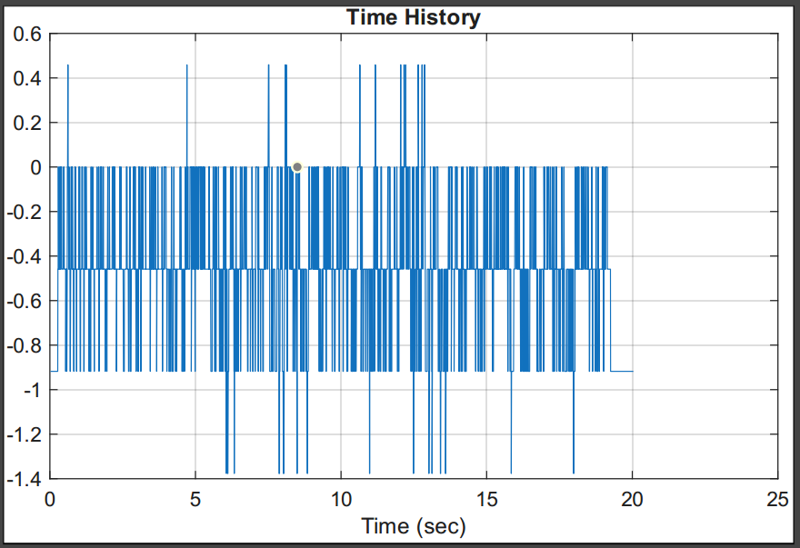
Figure 2. IIS2DH time history.
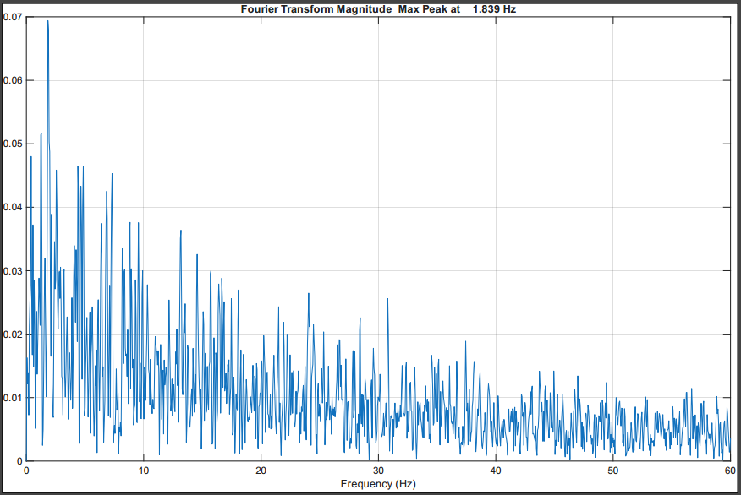
Figure 3. IIS2DH FFT magnitude (max peak at 1.839 Hz).
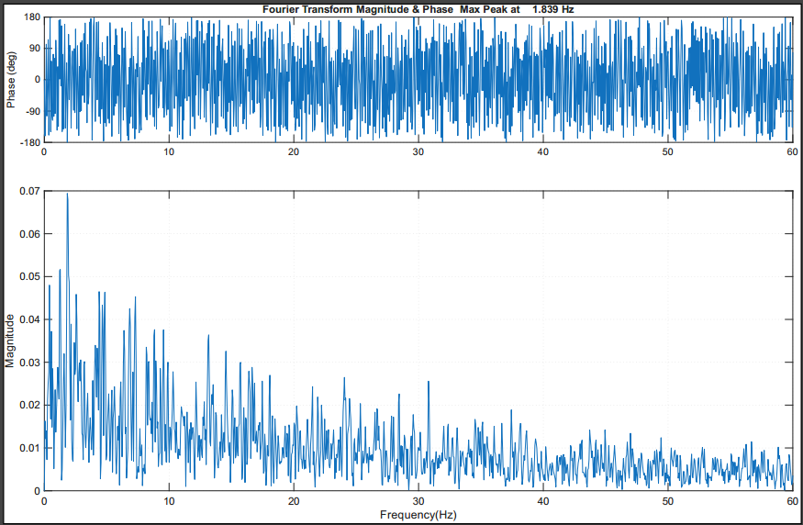
Figure 4. IIS2DH FFT magnitude and phase.

3.2 IIS3DWB
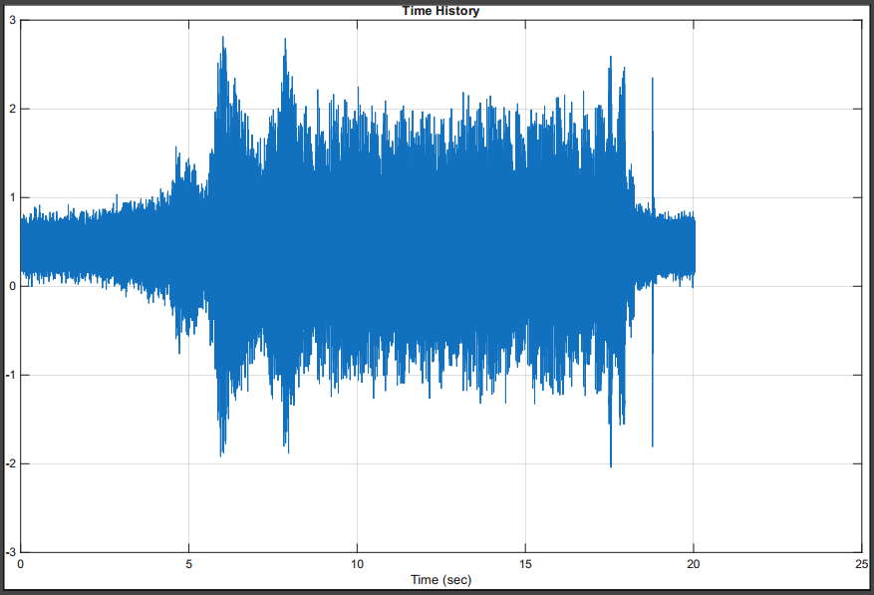
Figure 5. IIS3DWB time history.
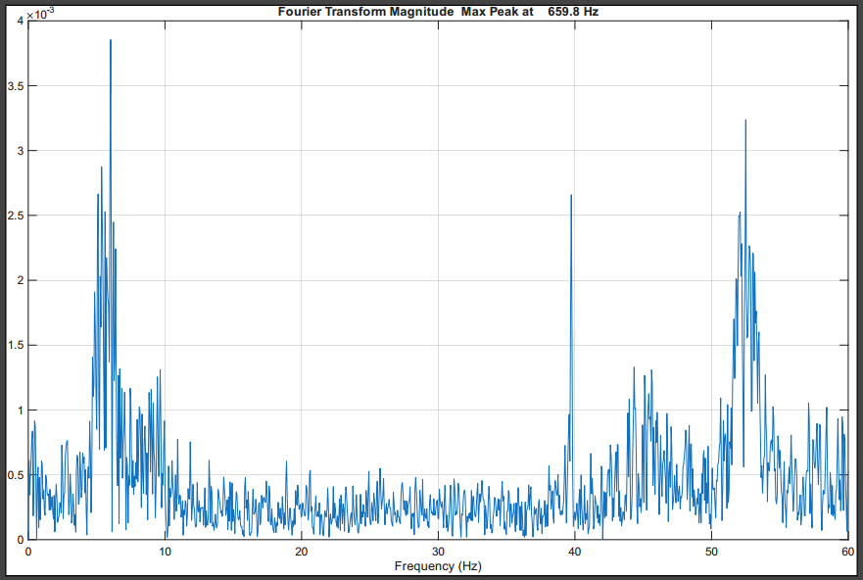
Figure 6. IIS3DWB FFT magnitude (max peak at 659.8 Hz).
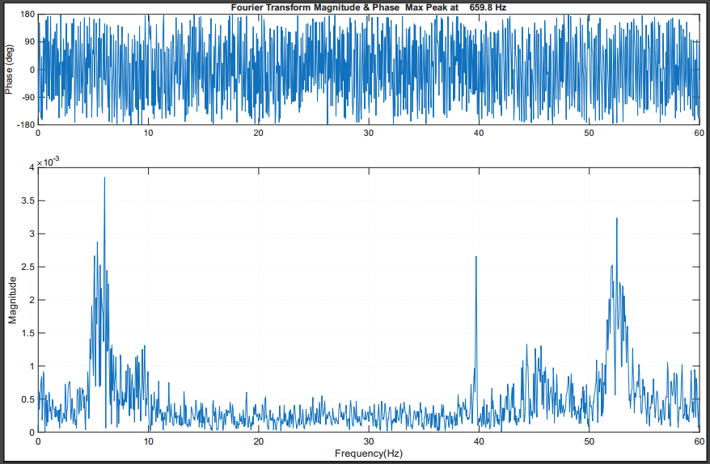
Figure 7. IIS3DWB FFT magnitude and phase.

3.3 ISM330DHCX
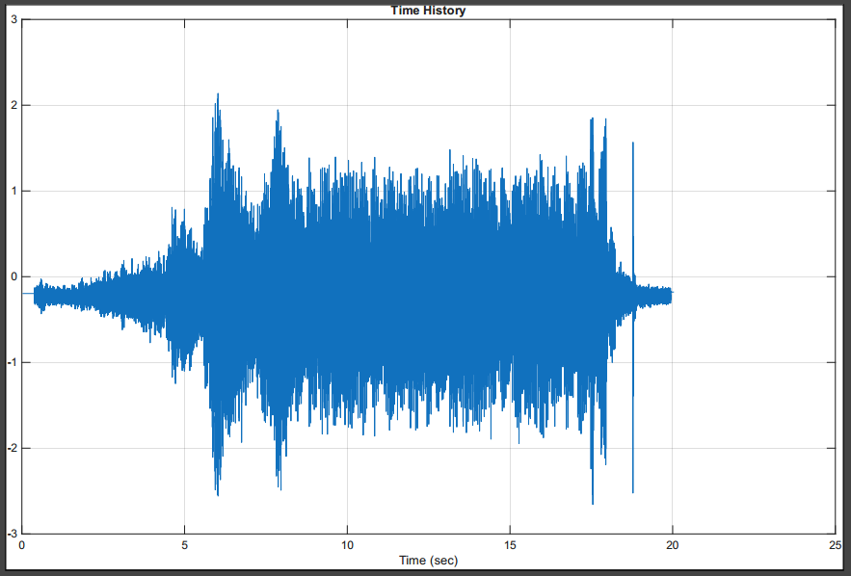
Figure 8. ISM330DHCX time history.
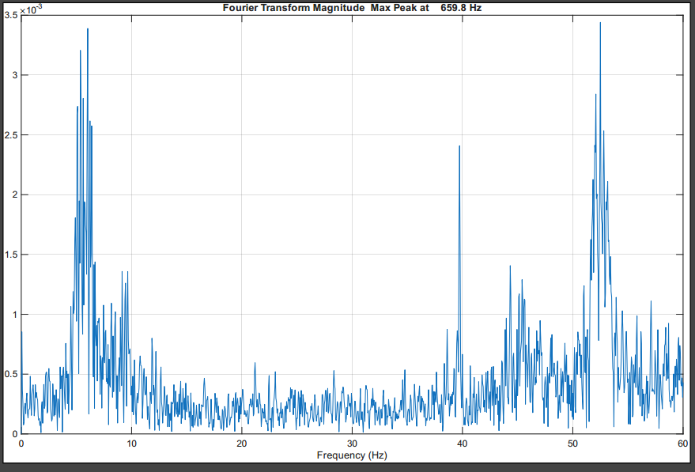
Figure 9. ISM330DHCX FFT magnitude (max peak at 659.8 Hz).
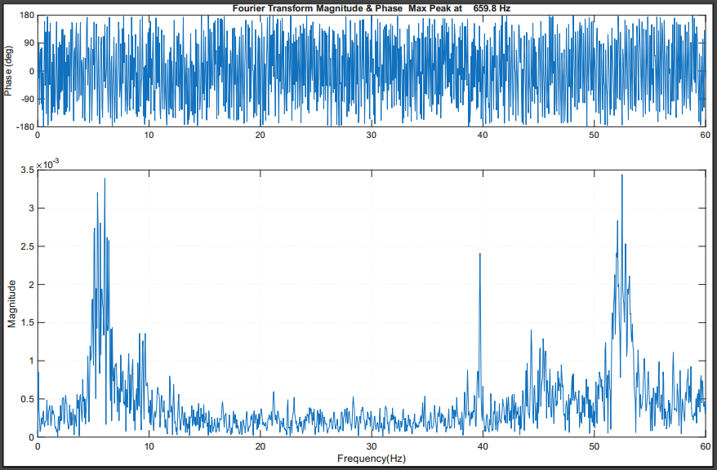
Figure 10. ISM330DHCX FFT magnitude and phase.

4. Question 2: Dynamic Range and Sampling Rate
The range setting in DeviceConfig.json is an index: 0 = ±2 g, 1 = ±4 g, 2 = ±8 g, 3 = ±16 g. The relevant lines for each accelerometer are listed below.

IIS2DH (config lines 342 to 371)
- Dynamic range: ±16 g
- Line 344: "fs": 3
- Sampling rate: 100 per second (line 346: "samples_per_ts": 100)

IIS3DWB (config lines 143 to 172)
- Dynamic range: ±4 g
- Line 145: "fs": 1
- Sampling rate: 1000 per second (line 147: "samples_per_ts": 1000)

ISM330DHCX (config lines 228 to 257)
- Dynamic range: ±64 g
- Line 262: "fs": 5
- Sampling rate: 1000 per second (line 264: "samples_per_ts": 1000)

5. Question 3: Maximum Frequency in the FFT
No frequency range was selected for the FFT. The plot max frequency field of the analysis tool showed 1.339e+04 Hz (about 13.39 kHz) for all three sensors (Figures 11 to 13). This is the upper limit of the frequency axis for the case where the motor speed increases from zero to maximum RPM.
Sensor | Input array | Max frequency shown
IIS2DH | iis2dh_all | 1.339e+04 Hz
IIS3DWB | iis3dwb_all | 1.339e+04 Hz
ISM330DHCX | ism330dhcx_all | 1.339e+04 Hz
Table 2. Maximum frequency shown in the FFT with no frequency range selected.
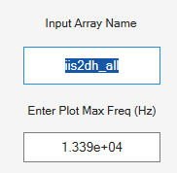
Figure 11. IIS2DH input array and plot max frequency.
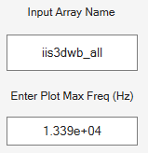
Figure 12. IIS3DWB input array and plot max frequency.
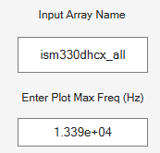
Figure 13. ISM330DHCX input array and plot max frequency.

6. Question 4: FFT of the Z-Direction
The z-direction signal of each accelerometer was built from the timestamp column and the z-axis column, converted to m/s² by multiplying by 9.81, using the MATLAB lines below.
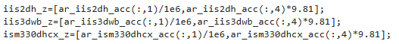
Figure 14. MATLAB lines used to build the z-direction signals.

6.1 IIS2DH, z-direction
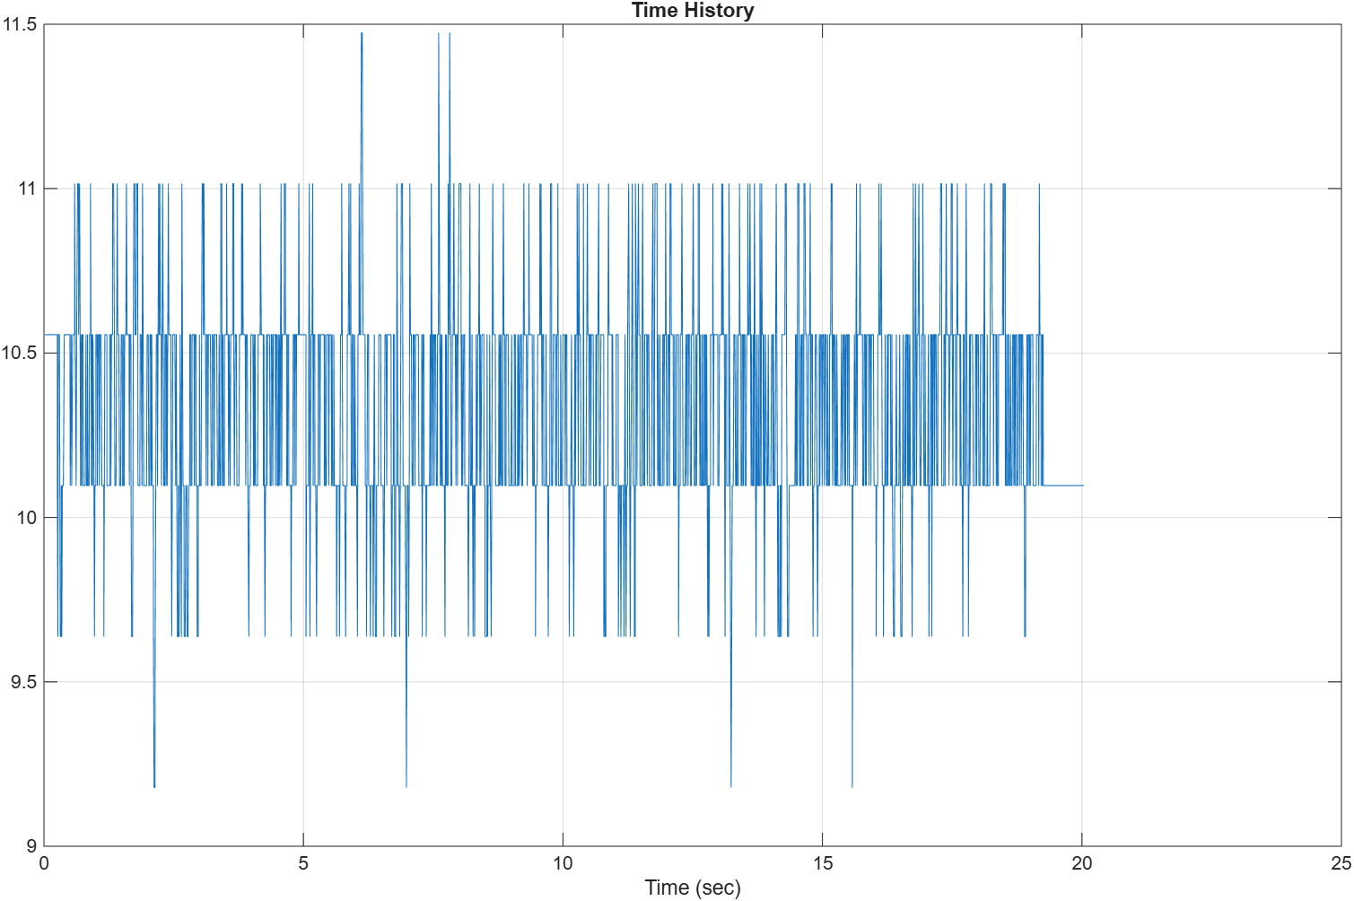
Figure 15. IIS2DH z-direction time history.
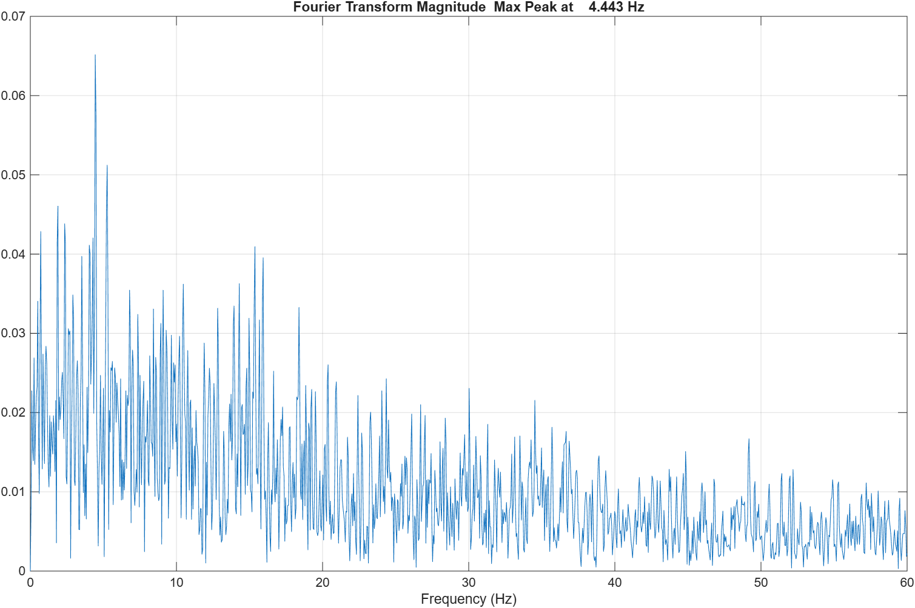
Figure 16. IIS2DH z-direction FFT magnitude (max peak at 4.443 Hz).
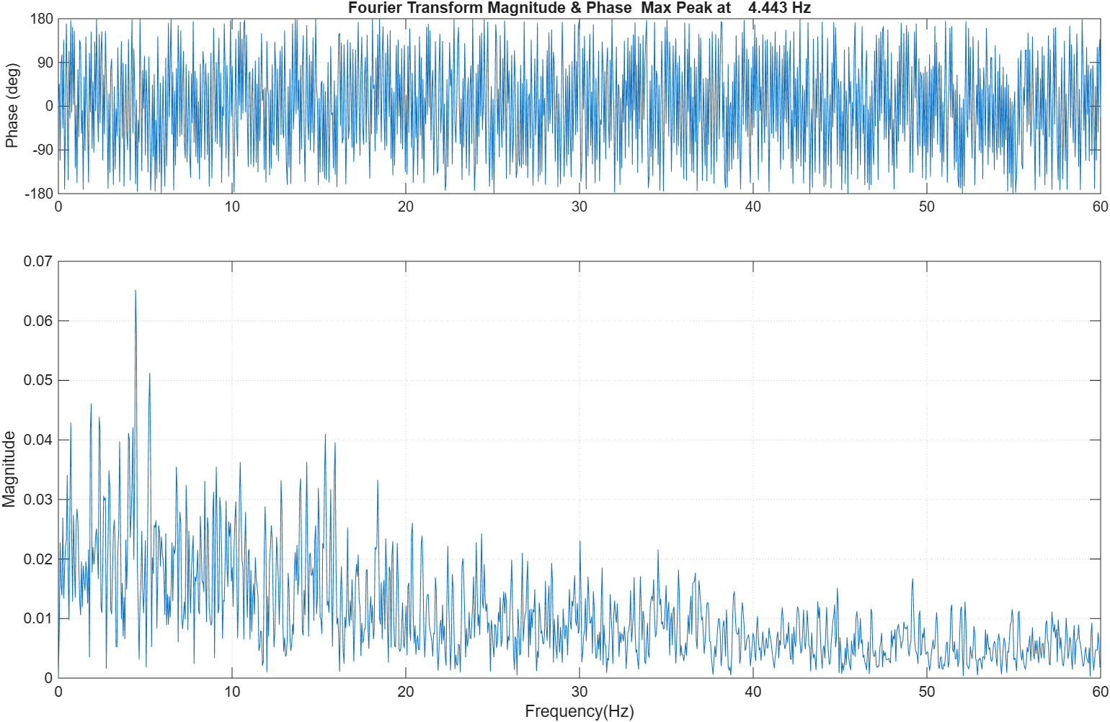
Figure 17. IIS2DH z-direction FFT magnitude and phase.

6.2 IIS3DWB, z-direction
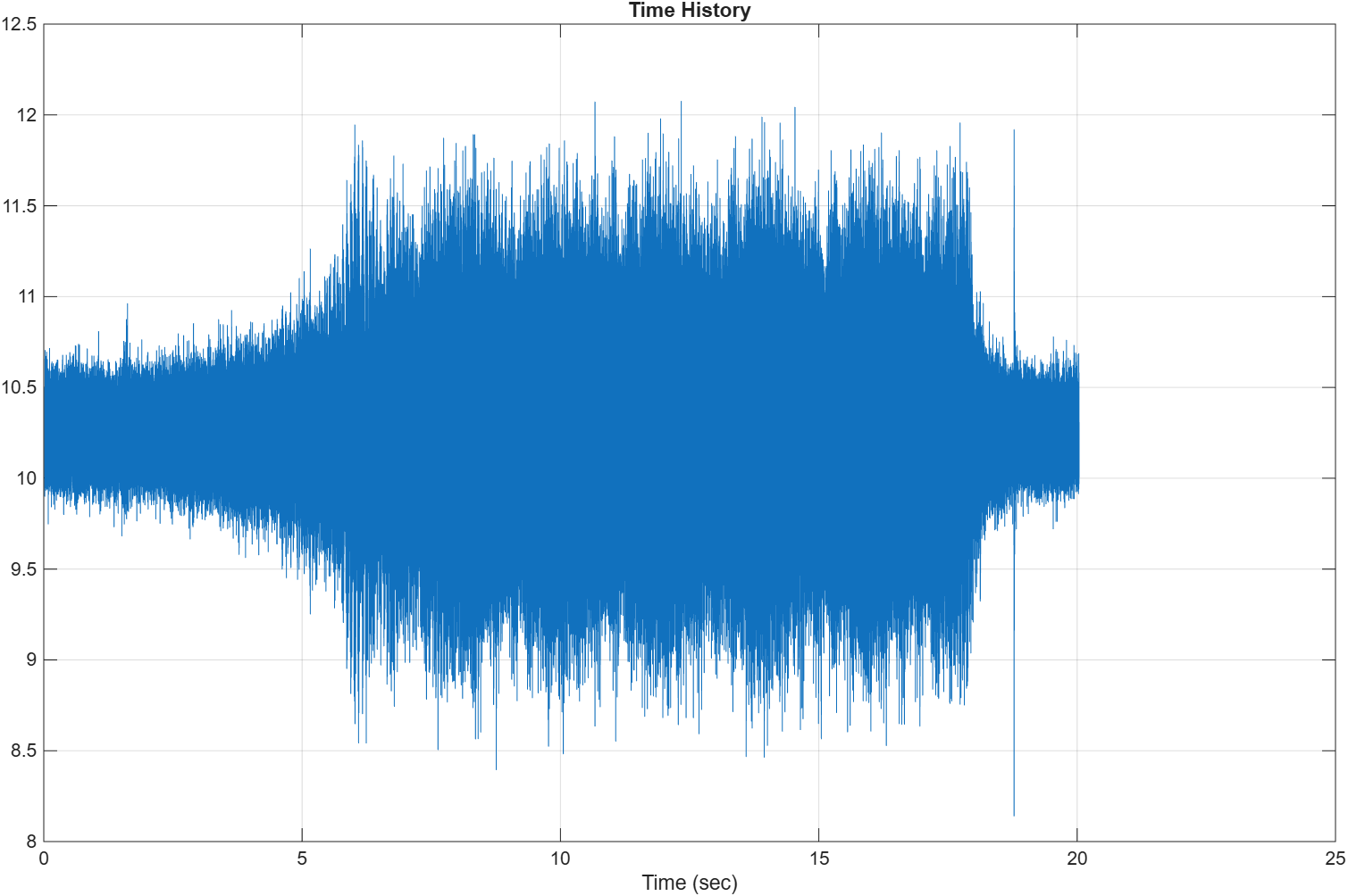
Figure 18. IIS3DWB z-direction time history.
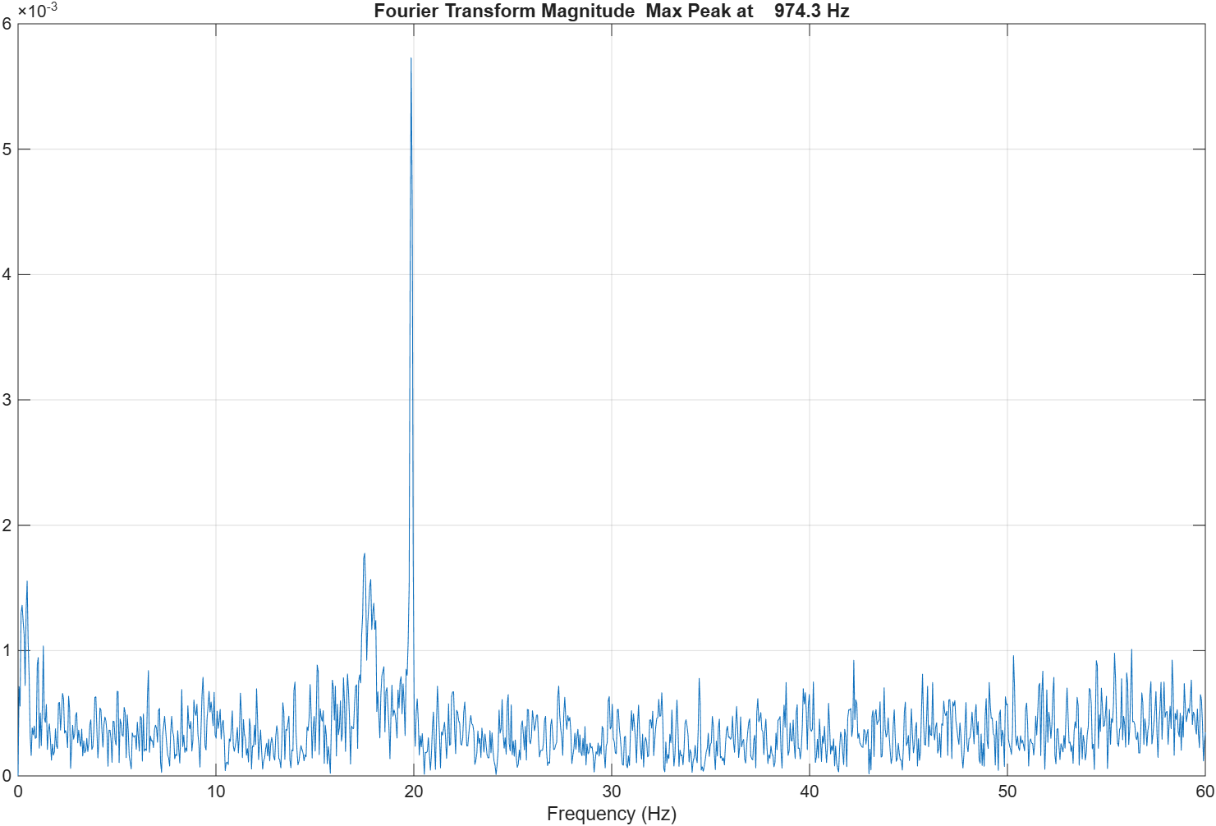
Figure 19. IIS3DWB z-direction FFT magnitude (max peak at 974.3 Hz).
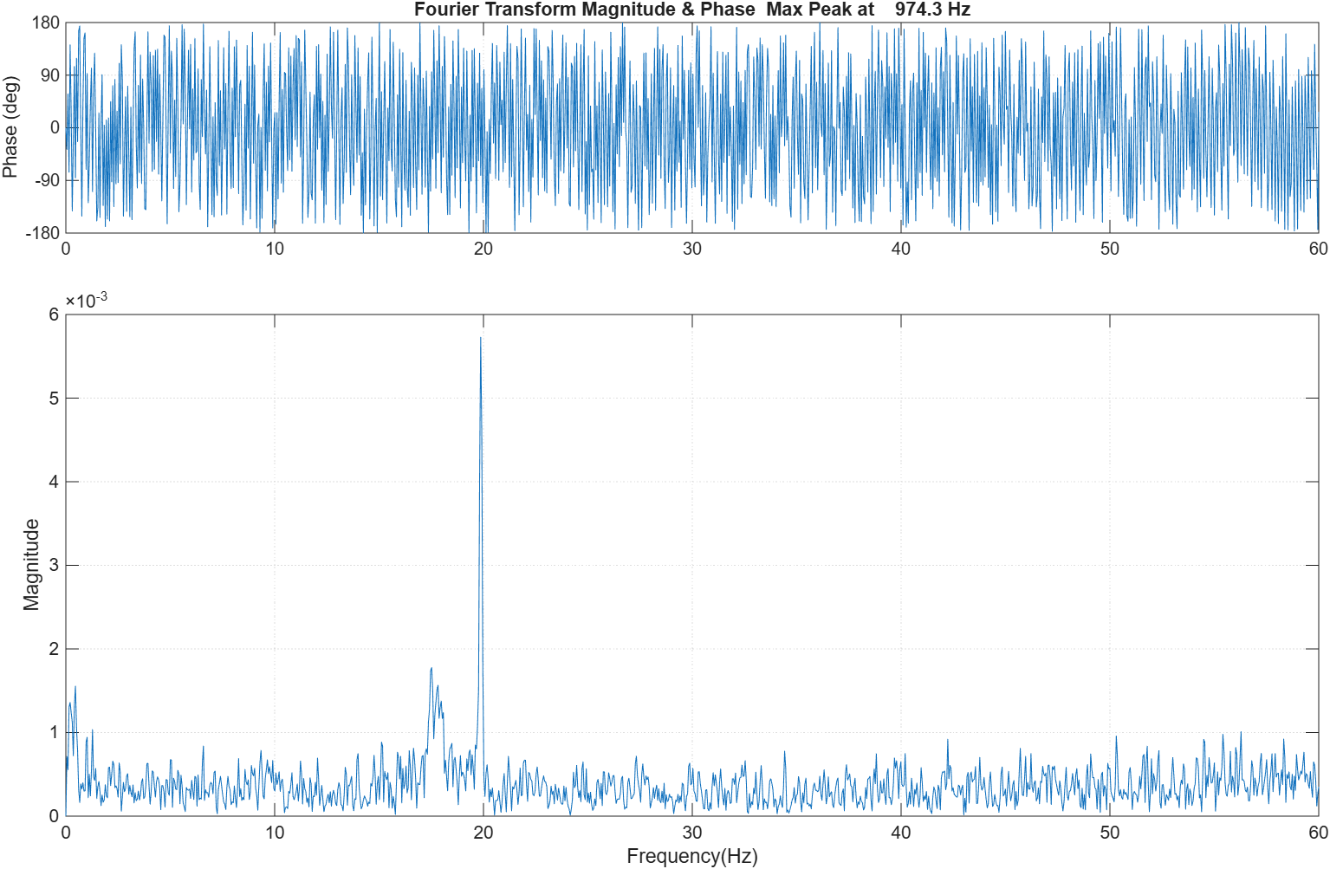
Figure 20. IIS3DWB z-direction FFT magnitude and phase.

6.3 ISM330DHCX, z-direction
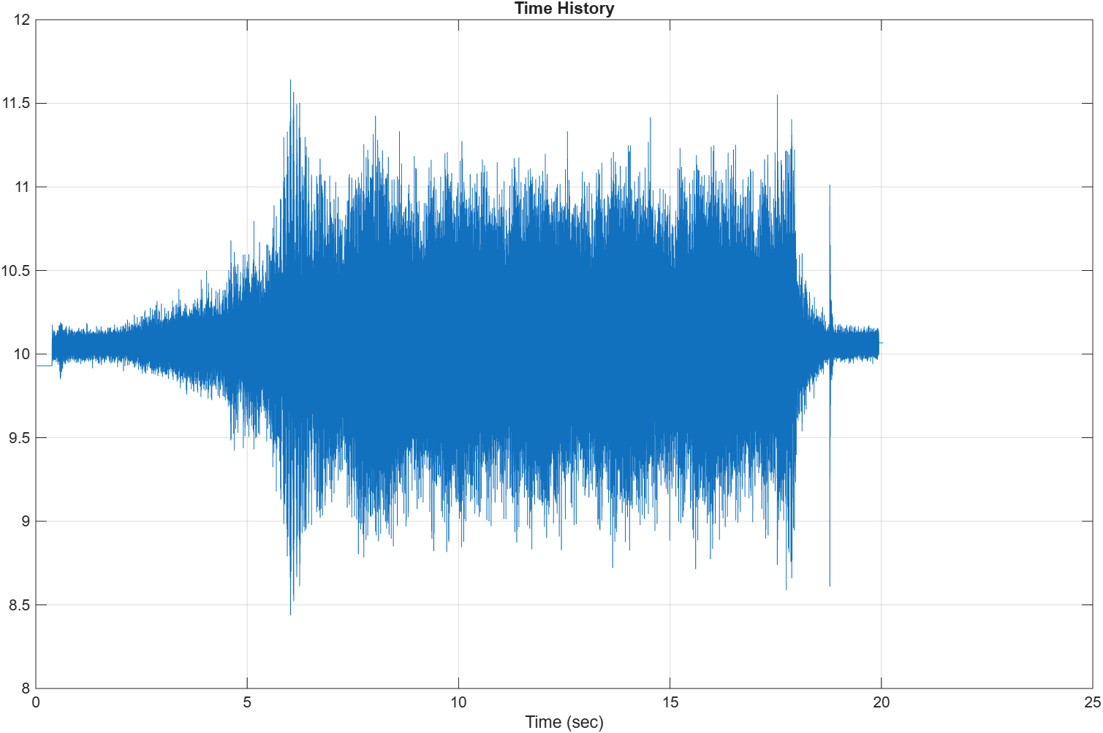
Figure 21. ISM330DHCX z-direction time history.
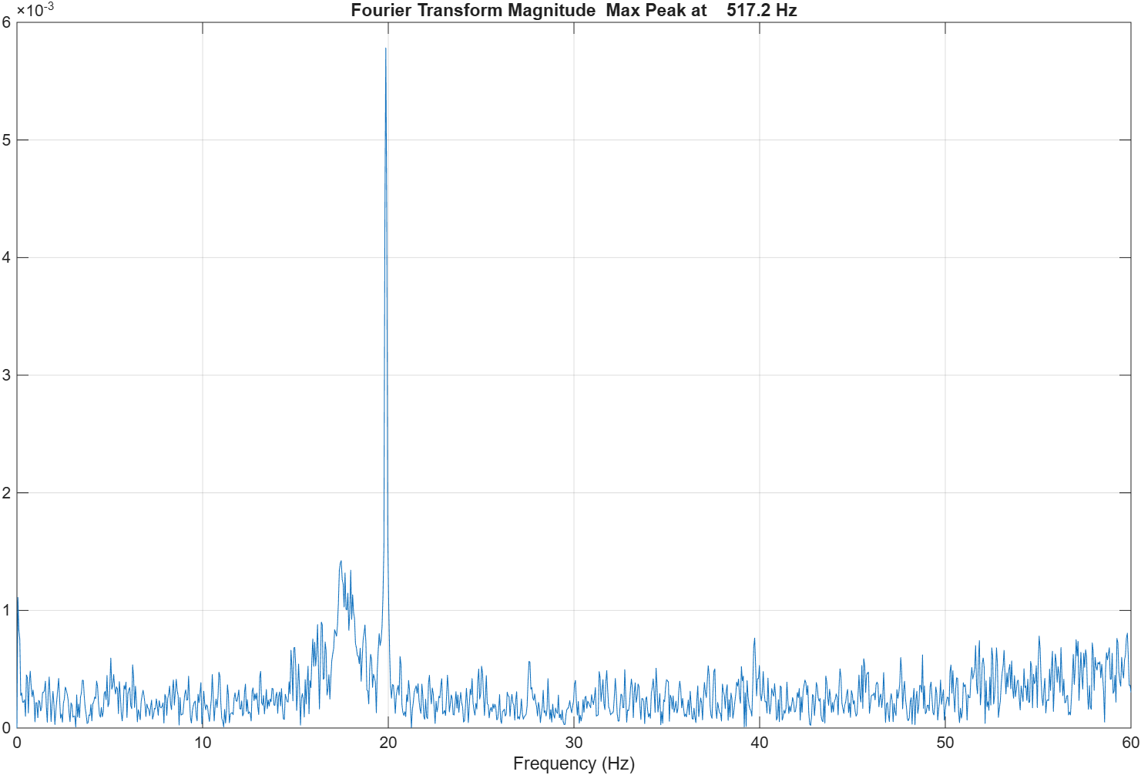
Figure 22. ISM330DHCX z-direction FFT magnitude (max peak at 517.2 Hz).
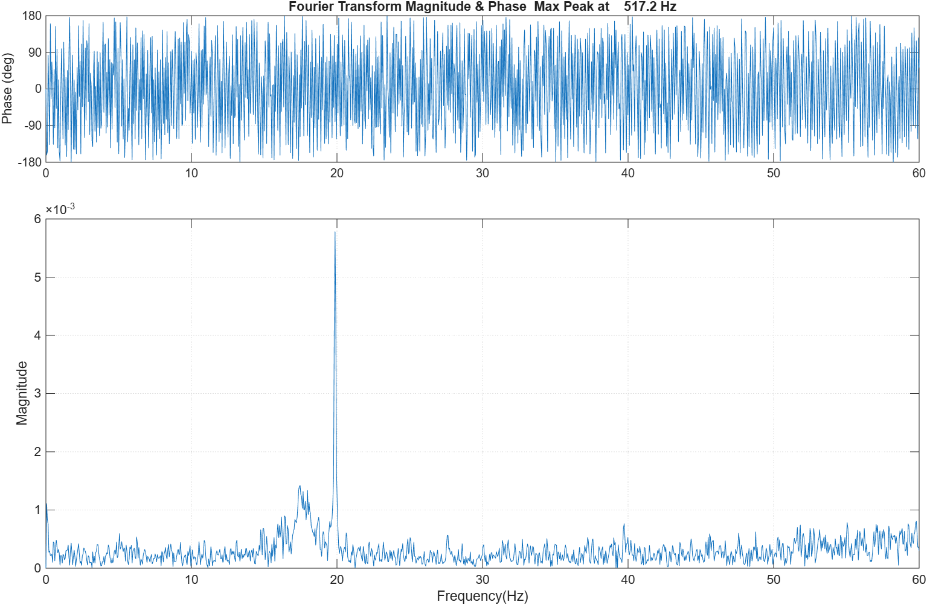
Figure 23. ISM330DHCX z-direction FFT magnitude and phase.
Sensor (z-direction) | Max FFT peak
IIS2DH | 4.443 Hz
IIS3DWB | 974.3 Hz
ISM330DHCX | 517.2 Hz
Table 3. Summary of the z-direction FFT results (peak values read from plot titles).

7. Question 5: Waterfall Plots (Z-Direction)
The waterfall plots show how the z-direction frequency content changes over the 20 second run, with time on one axis, frequency on the other and FFT magnitude vertically.
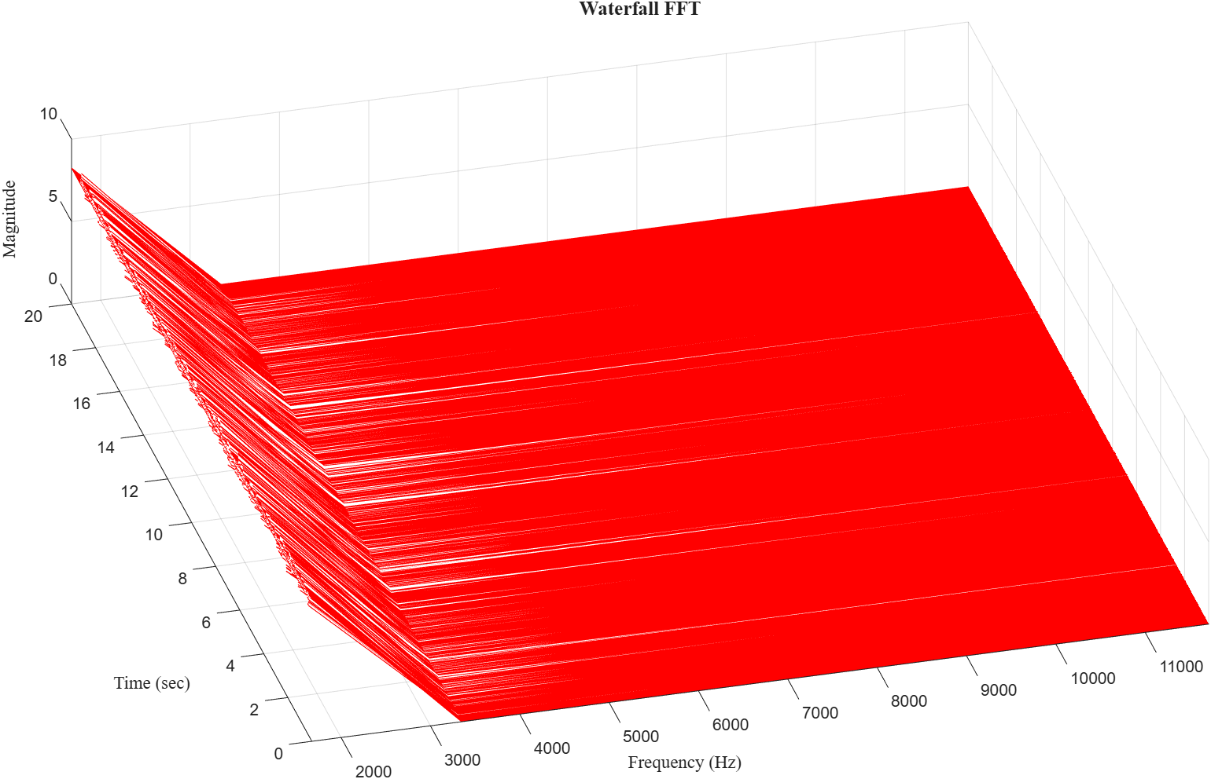
Figure 24. IIS2DH waterfall FFT, z-direction.
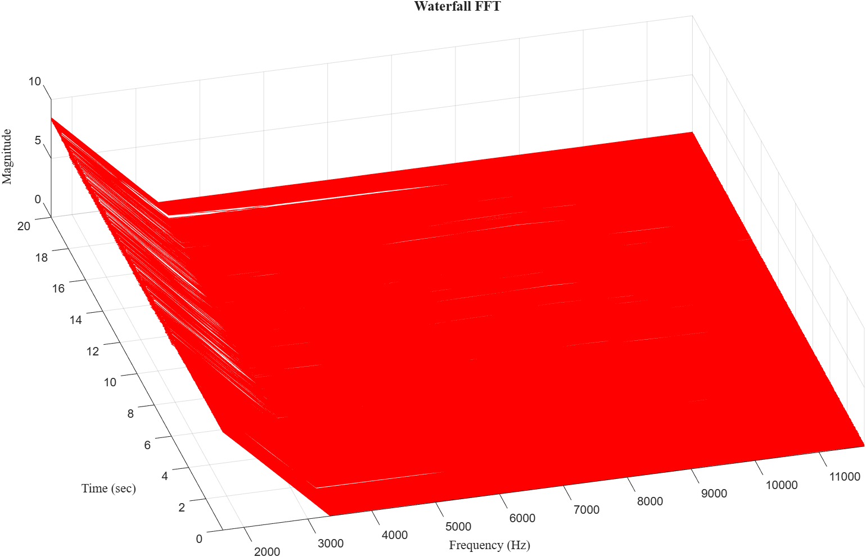
Figure 25. IIS3DWB waterfall FFT, z-direction.
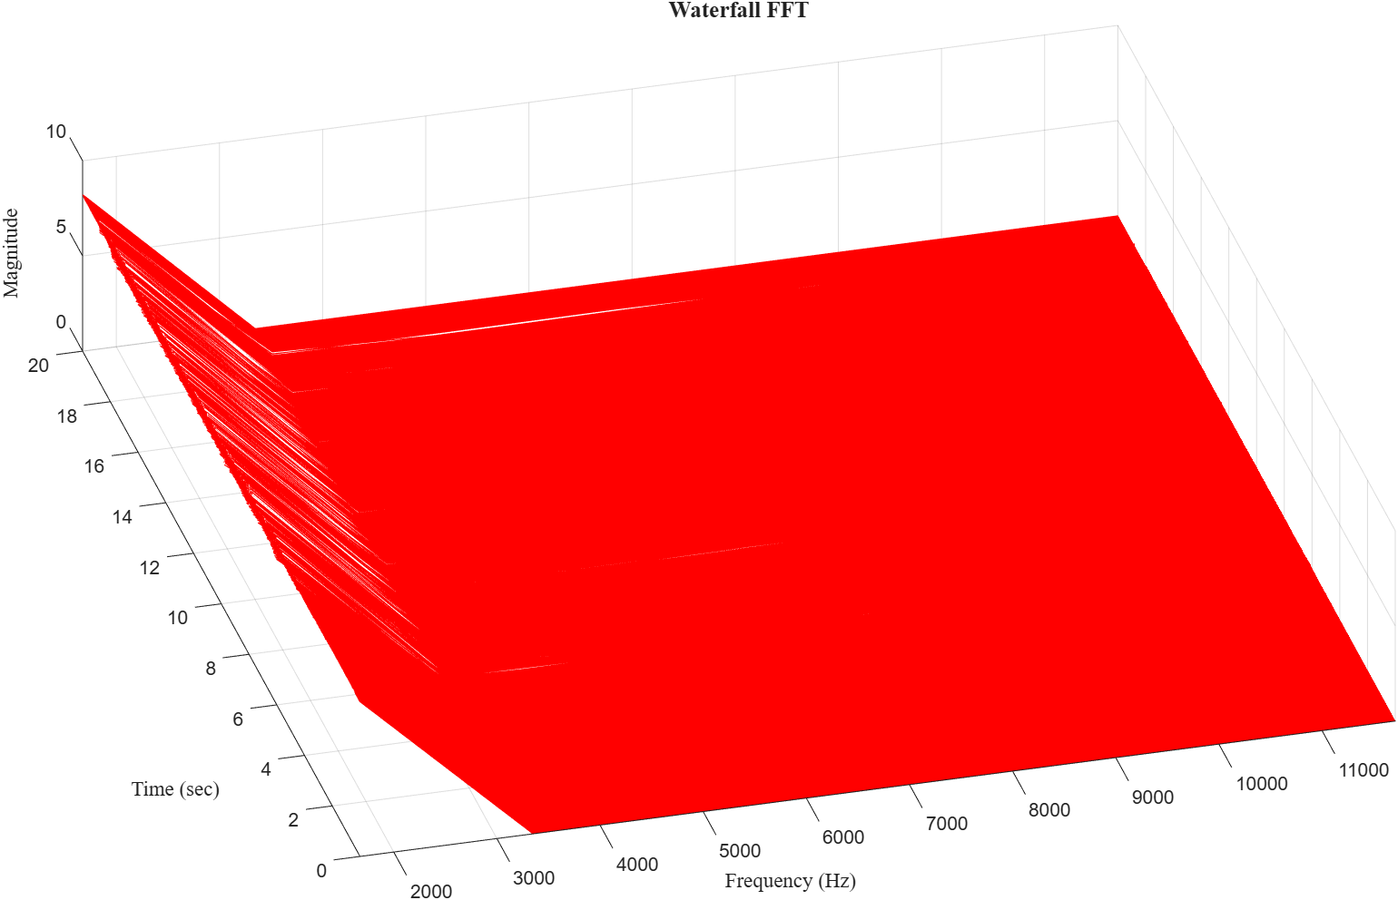
Figure 26. ISM330DHCX waterfall FFT, z-direction.

8. Conclusion
FFTs with a Hanning window were computed for the IIS2DH, IIS3DWB and ISM330DHCX accelerometers during a motor run-up. The configured ranges are ±16 g, ±4 g and ±64 g, with sampling rates of 100, 1000 and 1000 per second from DeviceConfig.json. With no frequency range selected, the FFT axis extends to 1.339e+04 Hz for all three sensors. The z-direction FFT peaks were found at 4.443 Hz (IIS2DH), 974.3 Hz (IIS3DWB) and 517.2 Hz (ISM330DHCX), and the waterfall plots show how the spectrum evolves with time as the speed increases.

